

**A Mini Project Synopsis on**

“CAREER RECOMMENDATION SYSTEM”

**Submitted**

**In fulfilment of the requirement for the VI Semester of Bachelor of Technology in Computer Science and Engineering of the academic year 2019-20**

**Submitted By**

|  |  |
| --- | --- |
| ***Shivani Sharma*** | ***R17CS384*** |
| ***Shivendra Saurav*** | ***R17CS385*** |
| ***Shiwani*** | ***R17CS387*** |
| ***Shubham Kumar Giri*** | ***R17CS392*** |

**Mini Project Group ID: G10**

**Section: G**

**Under the guidance of:**

Prof. Surendra Babu KN

**School of C & IT, REVA University**

**REVA UNIVERSITY**

**School of Computing and Information Technology**

**Bengaluru-560064**

**SCHOOL OF COMPUTING AND INFORMATION TECHNOLOGY**

This is to certify that the mini project entitled “CAREER RECOMMENDER SYSTEM” is a Bonafede work carried out by **SHIVENDRA SAURAV, SHUBHAM KUMAR GIRI, SHIWANI, SHIVANI SHARMA** bearing **R17CS385, R17CS392, R17CS387, R17CS384** respectively in partial fulfilment of 6th semester of Computer Science and Engineering program of Bachelor of Technology, REVA University during the academic year 2019-20. It is certified that all the corrections/suggestions indicated for internal assessment have been incorporated in the report deposited in the school library. The mini-project report has been approved as it satisfies the academic requirements in respect of mini-project prescribed for 6th semester of CSE program.

Signature of the Guide Signature of the Director

**Prof. Surendra Babu KN Dr. Sunilkumar S. Manvi**

**ACKNOWLEDGEMENT**

Any given task achieved is never the result of efforts of a single individual. There are always a bunch of people who play an instrumental role is leading a task to its completion. Our joy at having successfully finished our mini project work would be incomplete without thanking everyone who helped us out along the way. We would like to express our sense of gratitude to our REVA University for providing us the means of attaining our most cherished goal.

We would like to thank our Hon’ble Chancellor, Dr. P. Shyama Raju, Hon’ble Vice-Chancellor, Dr. S. Y. Kulkarni for their immense support towards students to showcase innovative ideas.

We cannot express enough thanks to our respected Director, Dr. Sunilkumar S. Manvi for providing us with a highly conducive environment and encouraging the growth and creativity of each student. We would also like to offer our sincere gratitude to our Mini Project Coordinators, Prof. Kiran M, Prof. Sailaja Thota, Prof. Surekha Thota and Prof. Ashok K. Patil for the numerous learning opportunities that have been provided.

We would like to take this opportunity to express our gratitude to our Mini Project Guide, Prof. Surendra Babu KN for continuously supporting and guiding us in our every endeavour as well for taking a keen and active interest in the progress of every phase of our Mini Project. Thank you for providing us with the necessary inputs and suggestions for advancing with our Mini Project work. We deeply appreciate the wise guidance that sir has provided.

Finally, we would like to extend our sincere thanks to all the faculty members, staff from School of Computing and Information Technology.

**Shivani Sharma**

**Shivendra Saurav**

**Shiwani**

**Shubham Kumar Giri**

TABLE OF CONTENTS

|  |  |  |
| --- | --- | --- |
| **Chapter** | **Name** | **Page Number** |
| Chapter 1 | Abstract | 5 |
| Chapter 2 | Introduction | 6-7 |
| Chapter 3 | Motivation | 7 |
| Chapter 4 | Literature Survey | 7 |
| Chapter 5 | Objective | 7-8 |
| Chapter 6 | System Requirements | 8 |
| Chapter 7 | Implementation Methods | 8-9 |
| Chapter 8 | Conclusion | 9 |
| Chapter 9 | References | 9 |

TABLE OF FIGURES

|  |  |  |
| --- | --- | --- |
| **Figure** | **Description** | **Page Number** |
| 1 | Data Acquisition Mode | 8 |
| 2 | Commands to run Flask | 9 |
| 3 | 1st Step of deployment | 10 |
| 4 | 2nd Step of deployment | 10 |
| 5 | 3rd Step of deployment | 11 |
| 6 | Continuation of 3rd Step of deployment | 11 |
| 7 | Result of the deployment | 12 |

ABSTRACT

Several researchers study recommendation systems to assist users in the retrieval of relevant goods and services, mostly used in e-commerce.

Several researchers study recommendation systems to assist users inthe retrieval of relevant goods and services, mostly used in e-commerce.

However, there is limited information of the impact of recommender systems in other domains like education. Thus, the objective of this study is to summarize the current knowledge that is available as regards recommendation systems that have been employed within the education domain to support educational practices. By performing a systematic mapping study, a total of 44 research papers have been selected, reviewed and analysed from an initial set of 1181 papers.

Our results provide some ﬁndings regarding how recommendation systems can be used to support main areas in education, what approaches techniques or algorithms recommender systems use and how they address different issues in the academic world. Moreover, this work has also been useful to detect some research gaps and key areas where further investigation should be performed, like the introduction of data mining and artiﬁcial intelligence in recommender system algorithms to improve personalization of academic choice Recommender systems are tools for interacting with large and complex information spaces. They provide a personalized view of such spaces, prioritizing items likely to be of interest to the user. The field, christened in 1995, has grown enormously in the variety of problems addressed and techniques employed, as well as in its practical applications. Recommender systems research has incorporated a wide variety of artificial intelligence techniques including machine learning, data mining, user modelling, case-based reasoning, and constraint satisfaction, among others. Personalized recommendations are an important part of many online ecommerce applications such as Amazon.com, Netflix, and Pandora. This wealth of practical application experience has provided inspiration to researchers to extend the reach of recommender systems into new and challenging areas. The purpose of the articles in this special issue is to take stock of the current landscape of recommender systems research and identify directions the field is now taking. This article provides an overview of the current state of the field and introduces the various articles in the special issue. Copyright © 2011, Association for the Advancement of Artificial Intelligence. All rights reserved.

published by one of Jane’s favorite authors, a cookbook by a new author and a supernatural thriller. Whether Jane will find these suggestions useful or distracting is a function of how well they match her tastes. Is the cookbook for a style of cuisine that she likes (and is it different enough from ones she already owns)? Is the thriller too violent? A key feature of a recommender system therefore is that it

INTRODUCTION

The prototypical use case for a recommender system occurs regularly in e-commerce settings. A user, Jane, visits her favourite online bookstore. The homepage lists current bestsellers and a list containing recommended items. This list might include, for example, a new book published by one of Jane’s favorite authors, a cookbook by a new author and a supernatural thriller. Whether Jane will find these suggestions useful or distracting is a function of how well they match her tastes. Is the cookbook for a style of cuisine that she likes (and is it different enough from ones she already owns)? Is the thriller too violent? A key feature of a recommender system therefore is that it provides a personalized view of the data, in this case, the bookstore’s inventory. If we take away the personalization, we are left with the list of best-sellers – a list that is independent of the user. The aim of the recommender system is to lower the user’s search effort by listing those items of highest utility, those that Jane might be most likely to purchase. This, of course, is beneficial to Jane as well as the e-commerce store owner.

Recommender systems research encompasses scenarios like this and many other information access environments in which a user and store owner can benefit from the presentation of personalized options. The field has seen a tremendous expansion of interest in the past decade, catalysed in part by the Netflix Prize (Bennett & Lanning, 2007) and evidenced by the rapid growth of the annual ACM Recommender Systems conference. At this point, it is worthwhile to take stock, to consider what distinguishes recommender systems research from other related areas of research in artificial intelligence, and to examine the field’s successes and new challenges. Systems that retrieve and ﬁlter the data through content and similar proﬁles are known as recommendation systems (RS). These systems are usually used within the e-commerce domain. For example, some websites, such as Amazon, through the application of RS allow offering the user recommendations for products that users do not know and could be of their interest. Suggested recommendations help to overcome the distressing search problem for the user. But this technology is not only used to sell

products, but it is also used to suggest videos (YouTube), movies (Netﬂix), friends (Facebook), among others.

This demand spans across several domains, among which is the educational domain. RS, which are applied in education, have the role of supporting teaching and learning activities through enhanced information retrieval. Nevertheless, there is limited information of the application of recommender systems in educational environments. Consequently, this study aims to summarize the current knowledge that is available concerning RS that have been employed to support educational practices.

This paper is structured as follows:

Section 2explains the research method and stages applied for the systematic mapping. Section 3provides the results of the mapping study. And ﬁnally, Sect. 4present our main conclusions.

MOTIVATION (IF ANY)

Each student gets suitable learning materials, exercises tailored to a student, adequate for his knowledge (mood, preferences, ...) mastery learning – fixed outcome, varied time (compared to classical education: fixed time, varied outcome)

LITERATURE SURVEY

Career Recommendation work resides in the domain of online recommender systems, which are widely adopted across many web applications, e.g., movie recommendations [12], e-commerce item recommendations [13], job recommendations [14] and so forth, where authors mainly concentrate on the relevance retrieval and ranking aspects of the recommendation system. There is insightful research and modelling of the hiring processes within job marketplaces. Such research includes work related to estimation of employee reputation for optimal hiring decisions [15], as well as work related to ranking and relevance aspects of job matching in labour marketplaces [16]. There has been work related to the theory of optimal hiring process, e.g., on the problem of finding the right hire for a job (the hiring problem), as well as on the classical secretary problem, where a growing company continuously interviews and decides whether to hire applicants [17,18]. Authors of [19] investigated job marketplace as a two-sided matching market using locally stable matching algorithms for solving the problem of finding a new job using social contacts. RS can be treated as one of the most efficient tools for business, aimed directly at increasing revenue and profitability as well as optimizing current product portfolio.

OBJECTIVES

As we mentioned in the previous section, the main goal of recommender systems in education is to help users find suitable resources for a better achievement of the learning goal in less time. However, the benefits of introducing educative recommender systems go beyond learning goals. Based on literature, we propose to classify the benefit from three points of views:

1. Student’s Performance:

Educational recommender systems can also help to identify students with problems and weakness. To detect student misconceptions, to help students to navigate in knowledge hyperspace, and to get a good quality information feedback.

ective, the main benefit is to find better quality resources and to reach the

ective, the main benefit is to find better quality resources and to reach the

1. Social Learning Enhancement:

One of the main features of collaborative recommender systems is the inclusion of social interaction and social navigation, where navigation history and bookmarks are visible to the others. In an educational context, this social attribute promotes student collaboration, helps to find like-minded people, and enhances virtual community experiences.

1. Increased Motivation:

There is also evidence that educational recommender systems have a positive feedback.

(Jie Chi, et al., 2009) by keeping them interested in the learning experience

Additionally, these systems have been shown to improve the atmosphere of the learning environment and enhance the interaction within the learning environment.

SYSTEM REQUIREMENTS

**Hardware Requirements**

|  |  |
| --- | --- |
| CPU | 2.0+ GHz or faster 32bit or 64bit CPU |
| Architecture | X86 or x64 architecture recommended |
| Physical Memory (RAM) | 256 MB |
| Hard Disk Space | 125.6 MB |
| Graphics Processor (GPU) | Intel HD 4000 or equivalent |
| Internet Connection | More than 10MBps connection |

**Software Requirements**

|  |  |
| --- | --- |
| Operating System | Windows, Linux, Mac OS |
| Platform | PowerShell, Command Prompt, Terminal |
| Microkernel | Flask |
| Browser | Google Chrome, Microsoft Edge |

**Functional Requirements**

1. Form View
2. Progress Bar
3. Text Type Input Fields
4. Drop Down Lists
5. Radio Buttons
6. Submit Button
7. Result View

**Non-Functional Requirements**

1. Security
2. Logging
3. Responsiveness
4. Accessibility
5. Performance
6. Compatibility

METHODOLOGY

**

**Fig 1:** Data Acquisition Mode

Data acquisition module: In data acquisition module, data from different users are collected and stored in dataset. These data consist of use profile, skills, past activities, browsing history. For this purpose, we are storing data in tab separated values (tsv) format files.

Transformation Module: Transformation stage deals with the different processes such as general information extraction and detail information extraction as per the requirement. If collaborative approach needs to be used in that case, we are going to transform data present in dataset into the user-user and user-item matrices to be analysed for recommendation.

Computation module: Computation module deals with the calculation part of the system It mainly consists of two parts - Data filtering and Result set generation. In the data filtering we need to analyse the similarity between item-item and user-item.

Recommendation Module: The last stage is the Recommendation unit where recommendations to the users are made depending upon the filtered results set from computation module.

EXPERIMENTAL RESULTS

While working on the given topic, we developed a questionnaire which is based on Flask (Python Microkernel) and HTML, CSS, and JavaScript to validate our theory. In this section we will explain how that program can be used to get a suitable career path.

1. Install Flask: Flask can be installed on either Linux or Windows using pip. Just run the given command.
   1. **pip install flask**
2. After this, open the terminal in which the project resides. Either GUI can be used or **cd** command can be used to open the directory.
3. Now enter the commands to start the development server.
   1. **set FLASK_APP = ”app.py”**
   2. **flask run**
4. After this a port will be provided which can be pasted and run in browser to initiate the project.
5. Once under project window, the first thing we need to do is enter Name, Email Address, and LinkedIn profile URL.
6. In the second step, Age, Form of Education Pursuing, and end year of the education pursuing must be entered
7. After this, user must select which soft skills they possess, which field they might be interested in and do they have any specific skills.
8. When clicked on Get Results, a field most suitable for the user based on the answers the user gave is displayed.

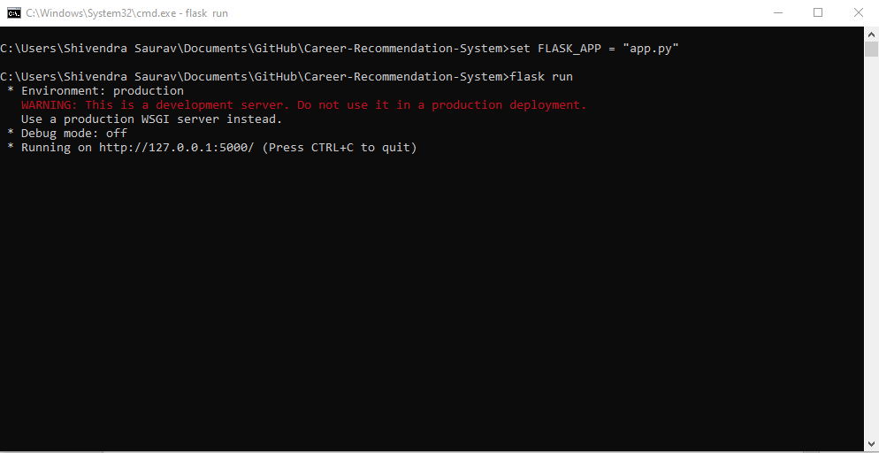

**Fig 2.** Step 3, and 4 showing the commands which are running and also the url generated for deployment server which is <http://127.0.0.1:5500/>.

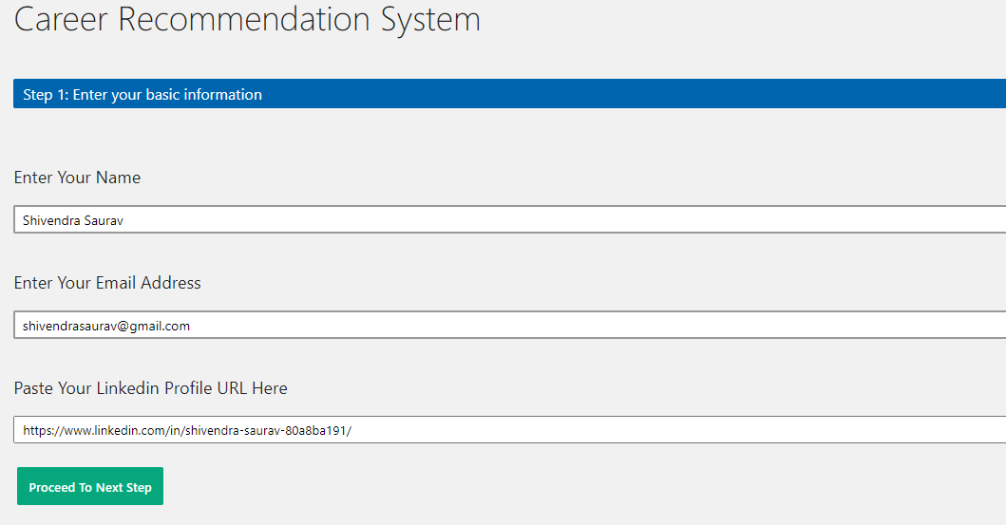

**Fig 3:** Showing step 5, the deployment window which opens and the first step in Questionnaire.

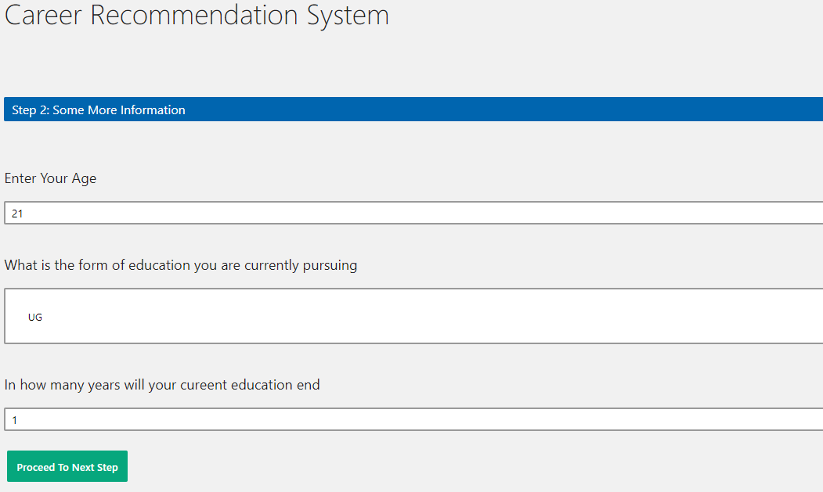

**Fig 4:** Shows step 6, Age and Basic Education Level Knowledge to be entered.

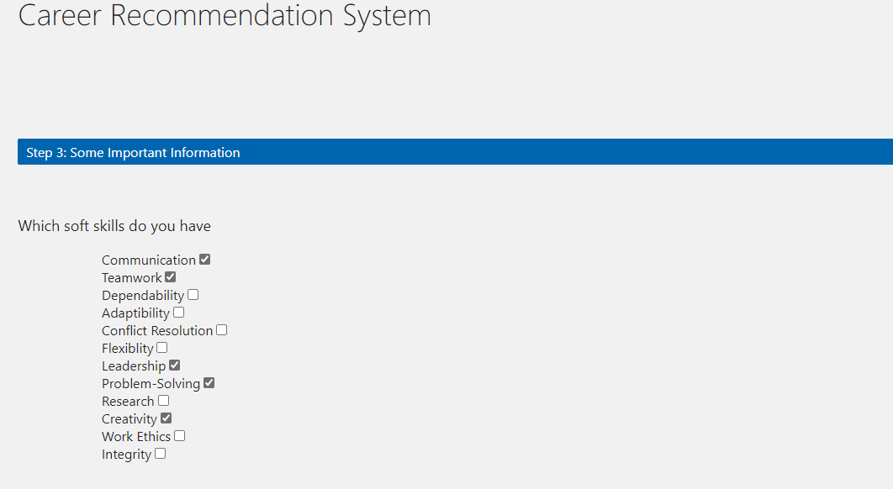

**Fig 5:** Selection of Soft Skills in step 7.

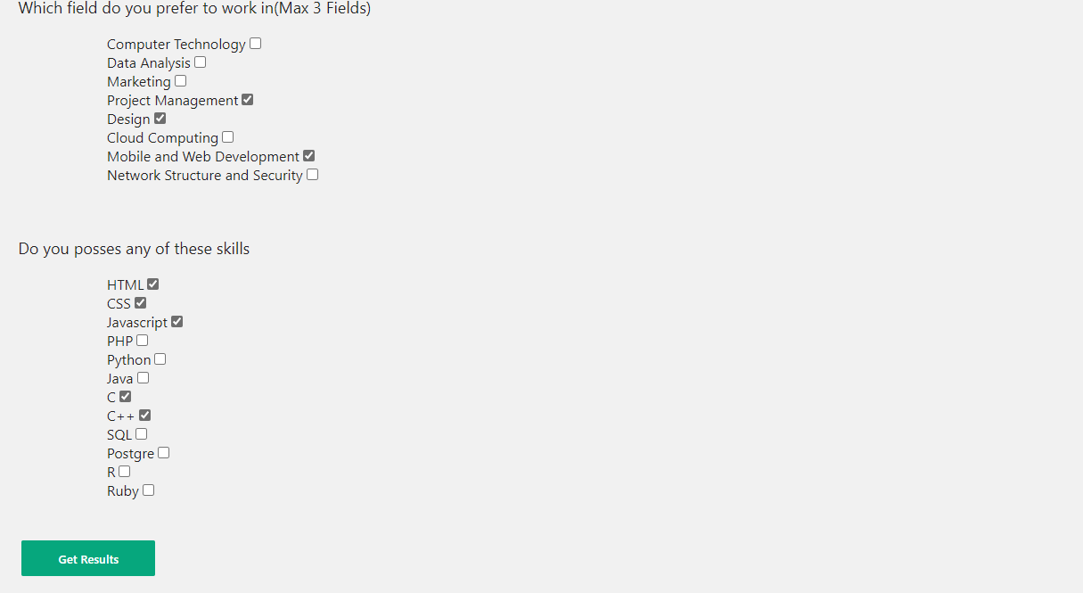

**Fig 6:** Still Continuing step 7, entering fields interested and skills which we might possess.



**Fig 7:** Clicking on Get Results in step 8 displays the best Career Choice out of bunch which the person who filled the questionnaire can follow.

CONCLUSION

In conclusion, the outcomes of this study will benefit the students in their career selection in which the process will become easier, flexible and faster. This is because self-testing can be done without the need of comprehensive mentoring by the counsellor. Furthermore, this study also measures student’s skill strengths, abilities and personality

facets and recommend them with possible career choices by using fuzzy logic approach. Moreover, this system also keeps the summary of career test where student can do the test repeatedly and can compare with the previous career test result.

FUTURE ENHANCMENTS

Even though this project works good to some extent, there’s always scope for enhancing and improving the project we are working on. Here, we would like to point out such enhancements or improvements which we can utilise to make our project even better.

1. We can Use Hybrid Filtering to get better results out of the bunch.
2. We can Use Neural Networks instead of hardcoding to give the results.
3. This project has only been made by keeping in mind a small group of people (CSE) it can further improve to include all the major studies and even students who are currently in schools to start this process from a grassroot level itself.
4. A better more engaging User Interface can be designed to make the application easier to use.

REFERENCES

* Salami, S.O., *Relationship between work values and vocational*
* *interests among high school students in Ibadan.* Nigerian African
* Journal of Educational Research, 1999. 5(2).
* [2] Talib, M.A. and T.K. Aun, *Predictors of Career Indecision Among*
* *Malaysian Undergraduate Students.* European Journal of Social
* Sciences, 2009. 8(2).
* [3] Moy, J.W. and S.M. LEE, *The Career Vhoice of Business*
* *Graduates: Real and Perceived Differences between SMEs and*
* *MNCs.* 2002. 7.
* [4] Holland, J.L., *Making Vocational Choice: A Theory of Personality*
* *Types and Models Environments.* 1973.
* [5] Holland, J.L., *Manuals for the Vocational Preference Inventory.*
* [7] Arora, M. and D. Tagra, *Nero-Fuzzy Expert System for Breast*
* *Cancer Diagnosis.* International Conference on Advances in
* Computing, Communications and Informatics, 2012

